

AMERICAN INTERNATIONAL UNIVESITY-BANGLADESH

**Faculty of Science and Technology**

Daycare Management System

**Course Teacher :** Kawser Irom Rushee

**Course Title :** INTRODUCTION TO DATABASE

# Section : J

**Group Members: 4**

|  |  |
| --- | --- |
| **Name** | **ID** |
| M.M.GOLAM HAFIZ | 22-48058-2 |
| PRITHOY CHANDRA ROY | 22-46424-1 |
| Md. Ahnaf Ibtahaz | 22-47700-2 |
| MD. AL RAFI SHOMPAD | 22-48010-2 |

**Table of Contents**

### Project Title, Name and ID of Group Members Page-1

1. **ER Diagram Scenario Page-3**
2. **ER Diagram using tool Page-3**
3. **Normalization of Database and Functional Dependencies Page-6**
4. **Table Creation with screenshots Page-10**
5. **Data insertion Page-20**
6. **Joining (1 Equijoin, 2 Outer join, 1 self- join) Page-25**
7. **Subquery (3 subqueries) Page-28**
8. **View (1 Complex view,1 simple view) Page-30**
9. **Adding a constraint Page-32**

**Er Diagram Scenario:**

In Daycare Management System, a parent can have their child taken care of by paying. A parent may have a specific parent ID. A parent is identified by a parent ID. The system also stores parent name, address & phone. A parent address is composed of country & city. There may be multiple phone number of a parent. A child is identified by child ID. Child name & birthdate is also stored. An admin is identified by admin ID. The system also stores admin name & phone number. There may be multiple phone number of an admin also. A staff is identified by staff ID. The system also stores staff name, phone & address. A staff may have multiple phone numbers. A parent pays an admin for the service. An admin manages staffs. A staff takes care of a child & reports to a parent. A staff must have at least a child to take care of & repot to the parent to get paid from the manager.

# ER Diagram using tool:

## At the beginning:

In middle:

Nearby end: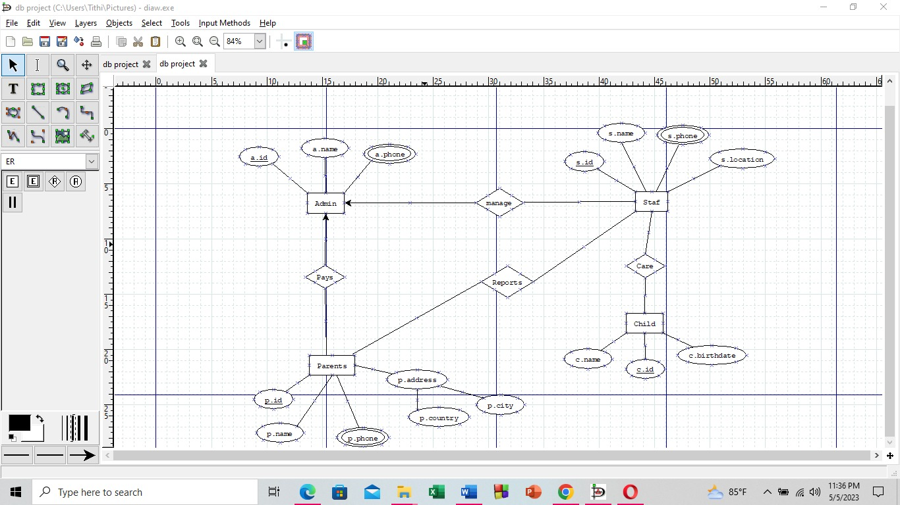

**Full ER Diagram:**

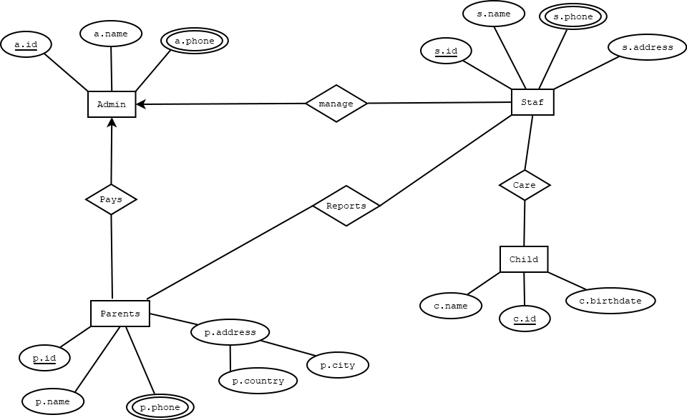

**Normalization of Database and Functional Dependencies:**

**Manage:**

UNF :   s.id, s.name, s. phone, s. address, a.id, a.name, a. phone

1NF :   s. phone and a. phone are multivalued

          s.id, s.name, s. phone, s. address, a.id, a.name, a. phone

2NF :

          1. a.name, a.id

2. a. phone, a.id(fk)

3. s.id, s.name, s. address, a.id(fk)

          4. s. phone, s.id(fk)

3NF :

          1. a.name, a.id

2. a. phone, a.id(fk)

3. s.id, s.name, s. address, a.id(fk)

          4. s. phone, s.id(fk)

**Care :**

 UNF : s.id, s.name, s. phone, s. address, c.name, c.id , c.birthdate

1NF  :  s. phone is  multivalued

          s.id, s.name, s. phone, s. address, c.name, c.id , c.birthdate

2NF :

1. s.id , s.name,s.address
2. s.phone , s.id(fk)
3. c.name, c.id, c. birthdate, s.id(fk)

3NF :

1. s.id , s.name
2. s.phone , s.id , s.addess
3. c.name, c.id, c. birthdate, s.id(fk)

**Reports:**

UNF : s.id, s.name, s. phone , s.address, p.id ,p.name , p. phone ,p. country,p.city

1NF   :   s.phone and p.phone are multivalued

  s.id, s.name, s. phone, s. address, p.id , p.name , p. phone ,p. country, p.city

2NF :

1. s.id, s.name, s.address
2. s.phone , s.id(fk)
3. p.id, p.name
4. p.phone , p.id, p.city  , p.country

3NF :

1. s.id, s.name
2. s.phone , s.id, s.address
3. p.id, p.name
4. p.phone , p.id
5. p.city  , p.country

**Pays :**

UNF: a.id , a.name , a. phone, p.id , p.name , p. phone , p. country , p.city

1NF : p.phone and  a. phone are multivalued

a.id , a.name ,a.phone, p.id , p.name , p. phone ,p. country, p.city

2NF :

1. a.name, a.id

2. a. phone, a.id(fk)

3. p.id, p.name, a.id

4.p.phone , p.id ,p.city , p.country

3NF :

1. a.name, a.id

2. a. phone, a.id(fk)

  3. p.id, p.name, a.id

4.p.phone , p.id

5. p.city  , p.country

**Final table :**

1. s.id , s.name
2. s.phone , s.id , s.addess
3. c.name, c.id, c. birthdate
4. p.id, p.name
5. p.phone , p.id
6. p.city  , p.country
7. p.id, p.name, a.id
8. a.name, a.id
9. a. phone, a.id
10. s.id, s.name, s. address, a.id
11. s. phone, s.id

**Table creation:**

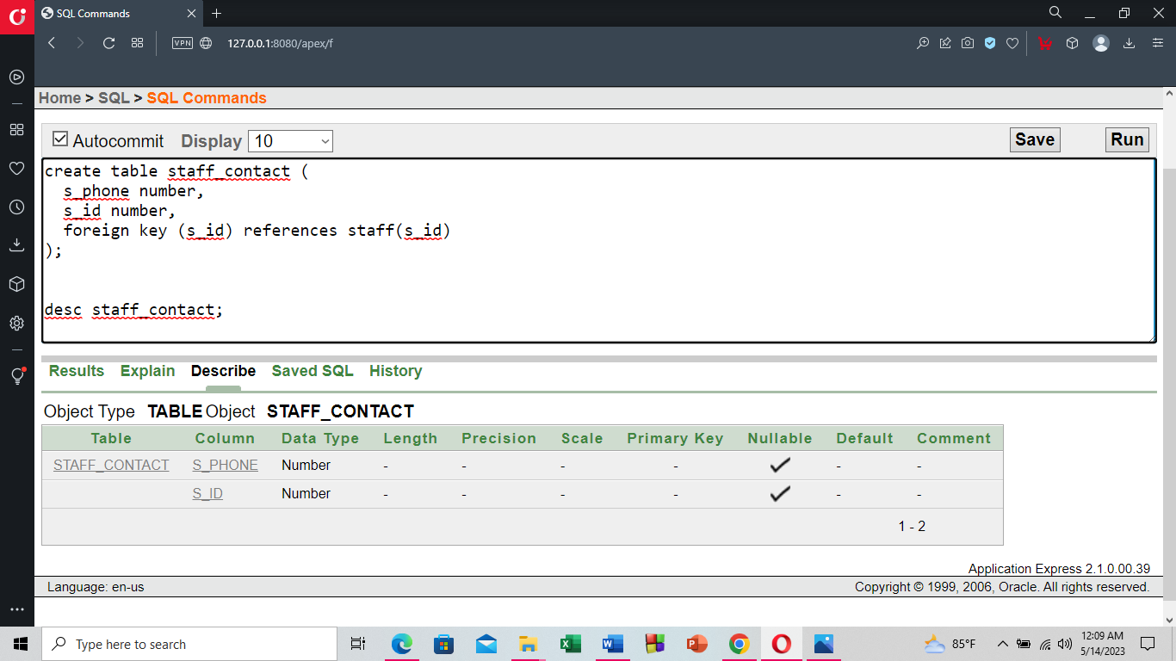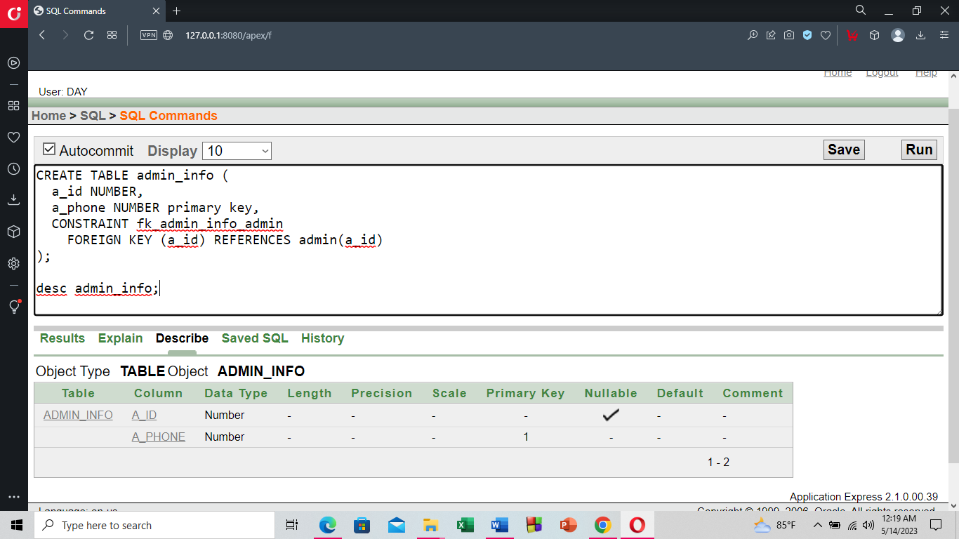

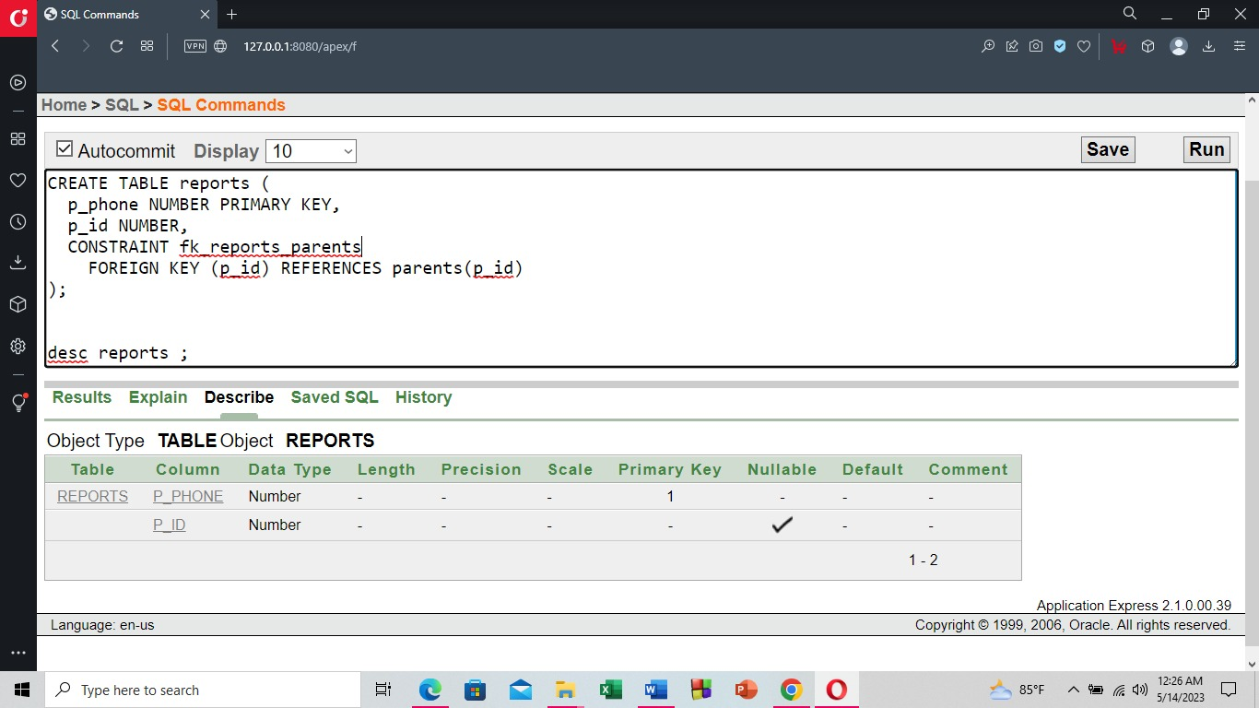

# Data Insertion:

**staff**

INSERT INTO staff (s_id, s_name)

VALUES (1, 'Rahim');

INSERT INTO staff (s_id, s_name)

VALUES (2, 'Karim');

INSERT INTO staff (s_id, s_name)

VALUES (3, 'Sakib');

**child**

INSERT INTO child (c_id, c_name, c_birthdate)

VALUES (1, 'Ifti', 2015);

INSERT INTO child (c_id, c_name, c_birthdate)

VALUES (2, 'Seyam', 2016);

INSERT INTO child (c_id, c_name, c_birthdate)

VALUES (3, 'Sumaya', 2014);

**admin**

INSERT INTO admin (a_id, a_name)

VALUES (1, 'Admin1');

INSERT INTO admin (a_id, a_name)

VALUES (2, 'Admin2');

INSERT INTO admin (a_id, a_name)

VALUES (3, 'Admin3');

**manager**

INSERT INTO manager (s_phone, s_id, s_address)

VALUES (123456789, 1, 'Khilkhet');

INSERT INTO manager (s_phone, s_id, s_address)

VALUES (987654321, 2, 'Rampura');

INSERT INTO manager (s_phone, s_id, s_address)

VALUES (456789123, 3, 'Bonani');

**Parents**

INSERT INTO parents (p_id, p_name)

VALUES (1, 'Samira');

INSERT INTO parents (p_id, p_name)

VALUES (2, 'Ovie');

INSERT INTO parents (p_id, p_name)

VALUES (3, 'Nadia');

**payment**

INSERT INTO payment (p_id, p_name)

VALUES (1, 'Payment1');

INSERT INTO payment (p_id, p_name)

VALUES (2, 'Payment2');

INSERT INTO payment (p_id, p_name)

VALUES (3, 'Payment3');

**reports**

INSERT INTO reports (p_id, p_phone)

VALUES (1, 123456789);

INSERT INTO reports (p_id, p_phone)

VALUES (2, 987654321);

INSERT INTO reports (p_id, p_phone)

VALUES (3, 456789123);

**address**

INSERT INTO address (p_city, p_country)

VALUES ('Dhaka', 'Bangladesh');

INSERT INTO address (p_city, p_country)

VALUES ('Cumilla', 'Bangladesh');

INSERT INTO address (p_city, p_country)

VALUES ('khulna', 'Bangladesh');

**admin_info**

INSERT INTO admin_info (a_id, a_phone)

VALUES (1, 123456789);

INSERT INTO admin_info (a_id, a_phone)

VALUES (2, 987654321);

INSERT INTO admin_info (a_id, a_phone)

VALUES (3, 456789123);

**staff_info**

INSERT INTO staff_info (s_id, s_name, s_address)

VALUES (1, 'Rahim', 'Dhaka');

INSERT INTO staff_info (s_id, s_name, s_address)

VALUES (2, 'Karim', 'Dhaka');

INSERT INTO staff_info (s_id, s_name, s_address)

VALUES (3, 'Sakib', 'Dhaka');

**staff_contact**

INSERT INTO staff_contact (s_phone, s_id)

VALUES (123456789, 1);

INSERT INTO staff_contact (s_phone, s_id)

VALUES (987654321, 2);

INSERT INTO staff_contact (s_phone, s_id)

VALUES (456789123, 3);

# Joining:

**1.Equijoin :**

SELECT *

FROM staff

**2.Outer Join :**

SELECT *

FROM staff

LEFT JOIN manager ON staff.s_id = manager.s_id;

**3.Outer Join :**

SELECT *

FROM staff

RIGHT JOIN manager ON staff.s_id = manager.s_id;

**4.Self-Join :**

SELECT s1.s_name AS parent_name, s2.s_name AS child_name

FROM staff s1

INNER JOIN staff s2 ON s1.s_id = s2.s_id;

# Subquery:

1.Show the staff members who have a phone number listed in the staff_contact table

2.Display all the employees who are earning more than any of the managers:

3.Show the names of all staff members whose id is present in the manager table

# Creating Views:

**Simple view :**

**Complex view :**

# Adding Constraint:

